**Major Life Skills Activities carried out at each Centres**

1. **Art & Craft :**During 2022-23, at each CLCs many sessions on art and craft were organised for the children. Arts education provides students with a creative outlet that can improve their problem-solving skills. They learn how to think outside the box and explore topics in an unconventional way. Free hands are given to the children for art and drawing to enhance their creativity and imagination skills. At the same time art and craft develops their hands on skills for making things and also encourages playing and exploring in fun way.

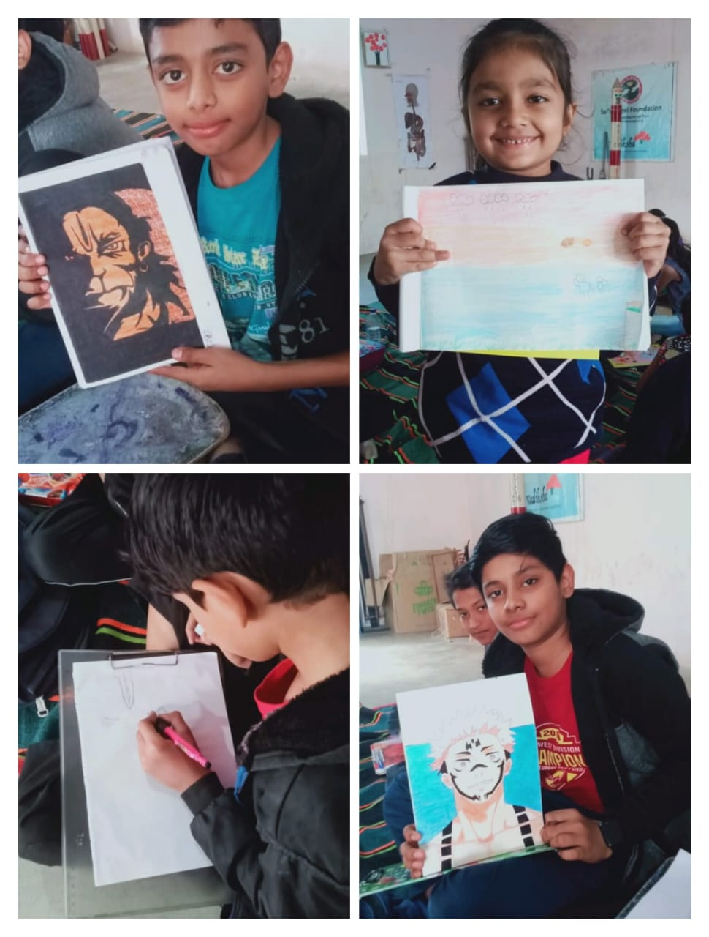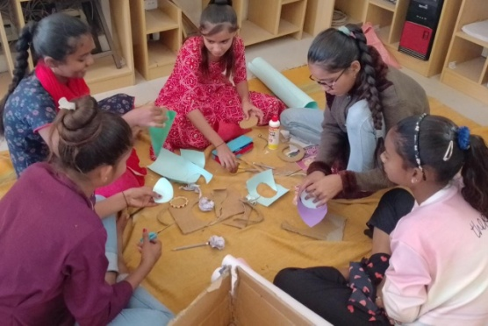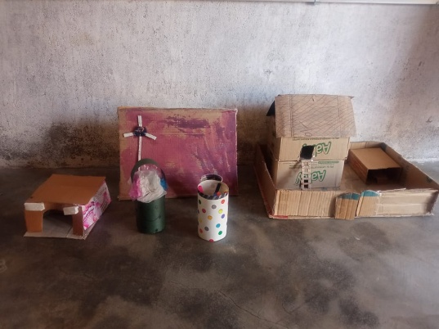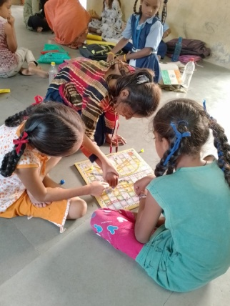

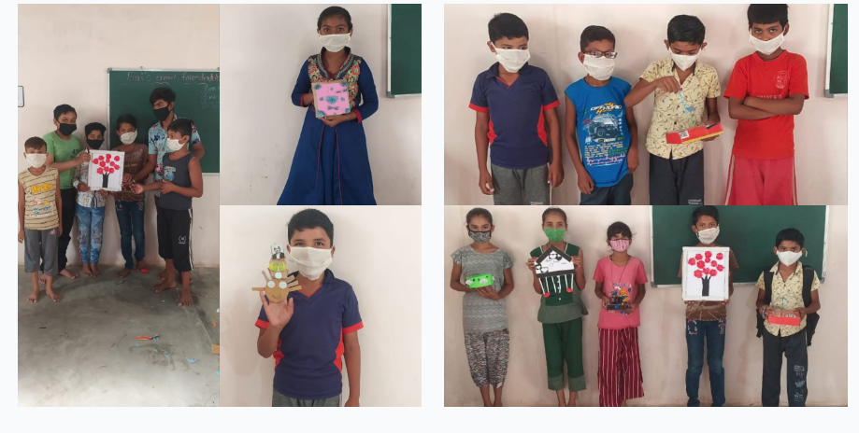

1. **Celebration of various festivals:** India is a country known for it’s rich culture and heritage. Festivals are symbol of reflecting culture of any country. This teaches students about their roots in the world and makes them proud of their country and culture. It is during festivals when stories of the past come forward to teach children about the past and help them understand the importance of celebration through generations. At CLCs all major festivals are celebrated such as Independence day, Republic day, Navratri, Ganesh Festival, celebration of birth anniversary of many leaders such as Gandhi Jaynti, Buddha Purnima and many others. Activities include cultural program, singing, dancing, writing essays on leaders and discussions on the festival themes.

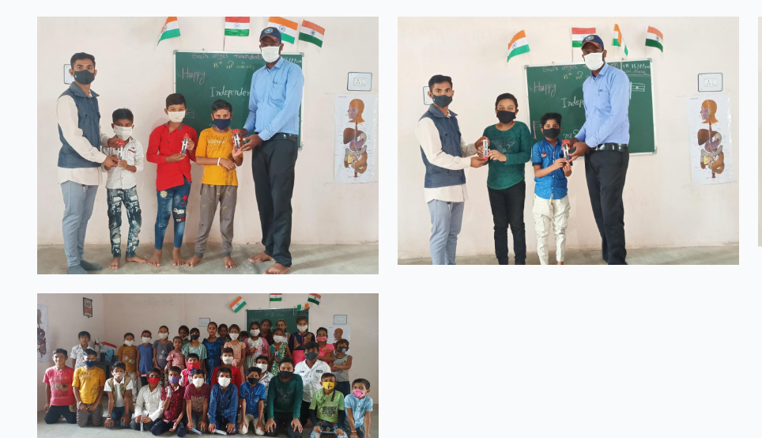

1. **Enhancing English Language of students:** Special activities are being carried out on Saturdays where through games on spellings, words and discussions English language is being taught in fun and play way.

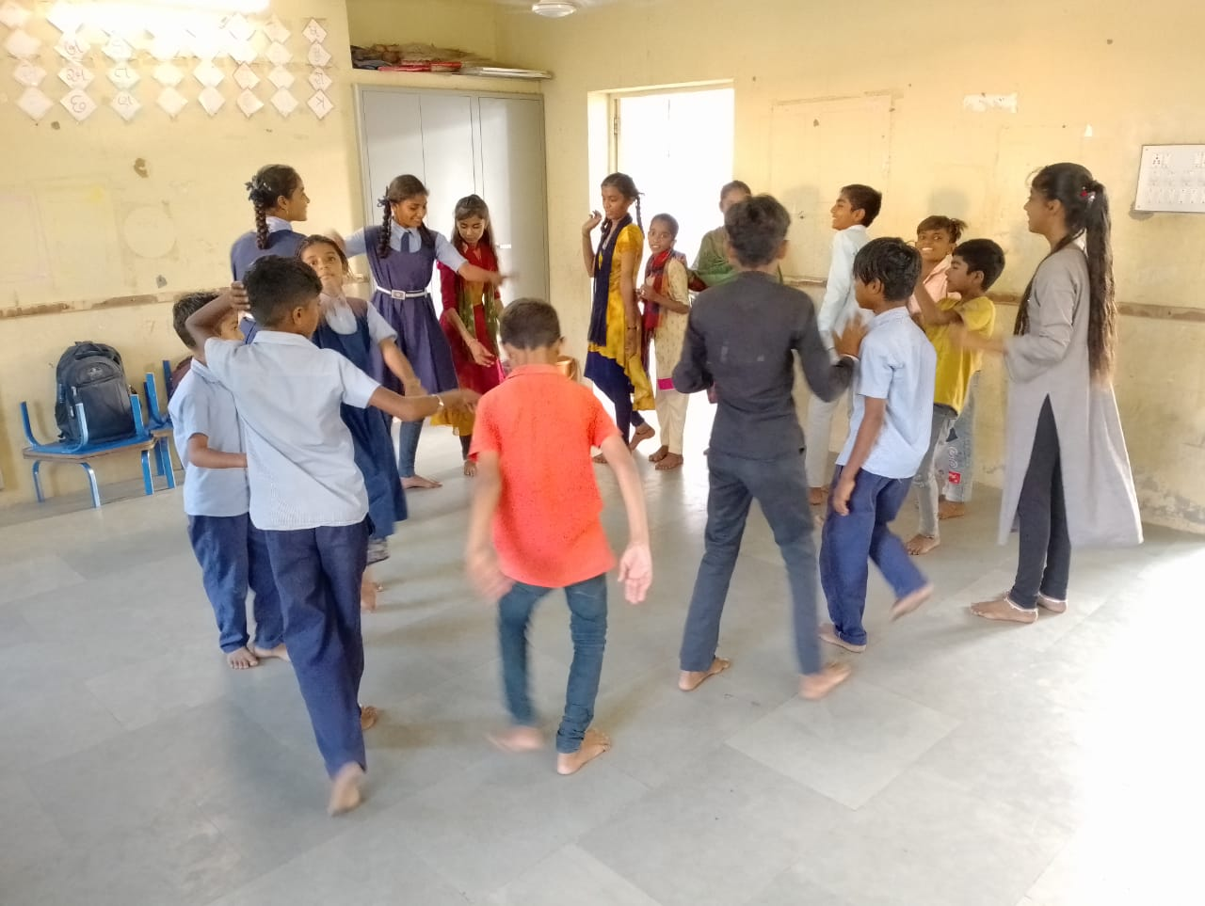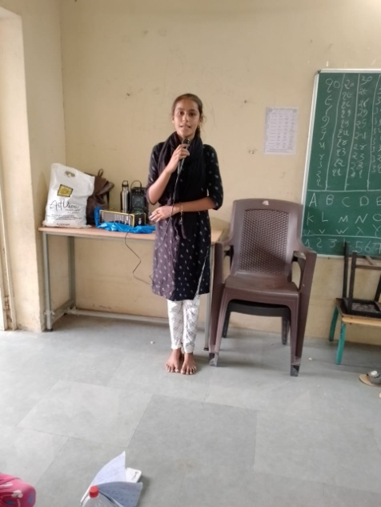

1. **Yoga and exercises :** As SAF is always focuses on overall development of the students, health of students is one of the most important parameter that it considers. Yoga and exercises were also carried out on regular basis for the children.
2. 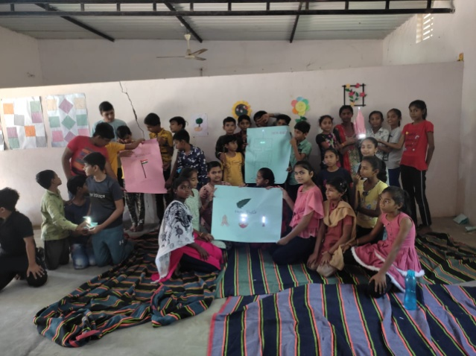**Science Activities :** SAF runs it’s own STEM program hence, many of the STEM activities were carried out with CLC kids such as making of paper circuit, Science model making and making ink from flowers. These activities promote the interest of the students towards science and Maths subject

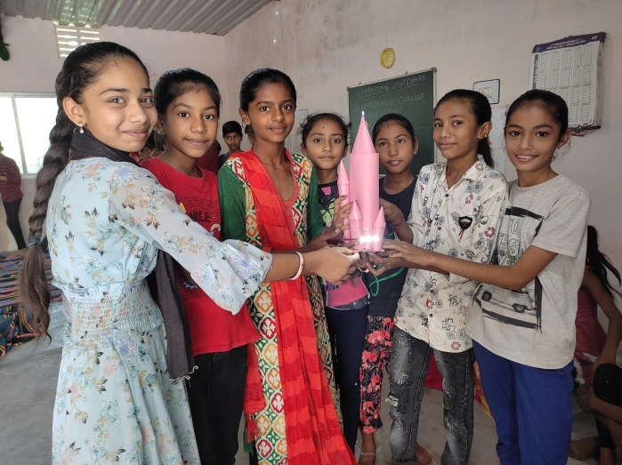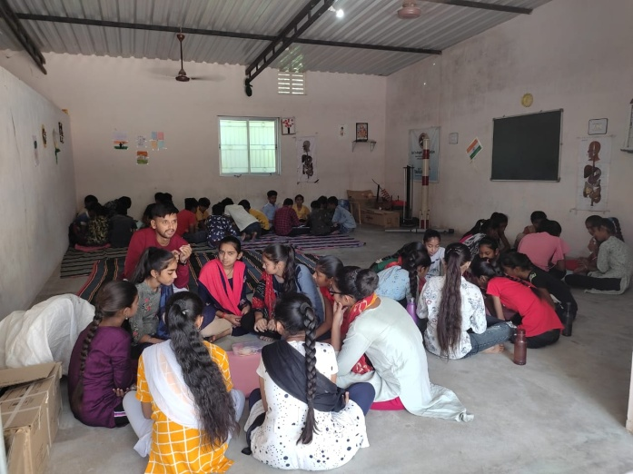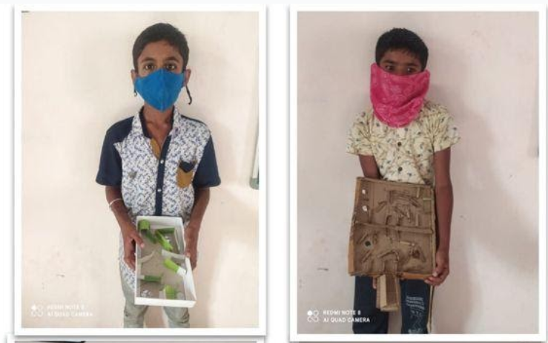

1. 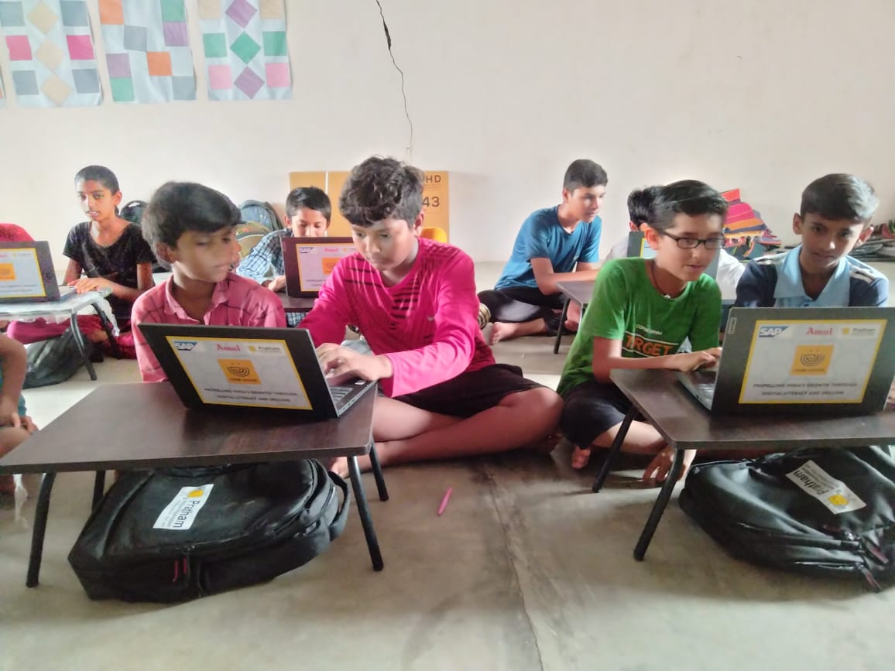**Remedial coaching:** Covid-19 has created worse effect on basics of students especially in Maths, Gujarati and English. SAF CLC staff pays special attention to the students who are facing difficulties in fundamentals. Staff makes lot of efforts to bring them into mainstream.
2. **Digital Learning ;** During vacation time, SAF with the help of Pratham NGO, provided digital learning to the students at CLCs. Children learnt basics of Computers and some of the digital art in laptops.

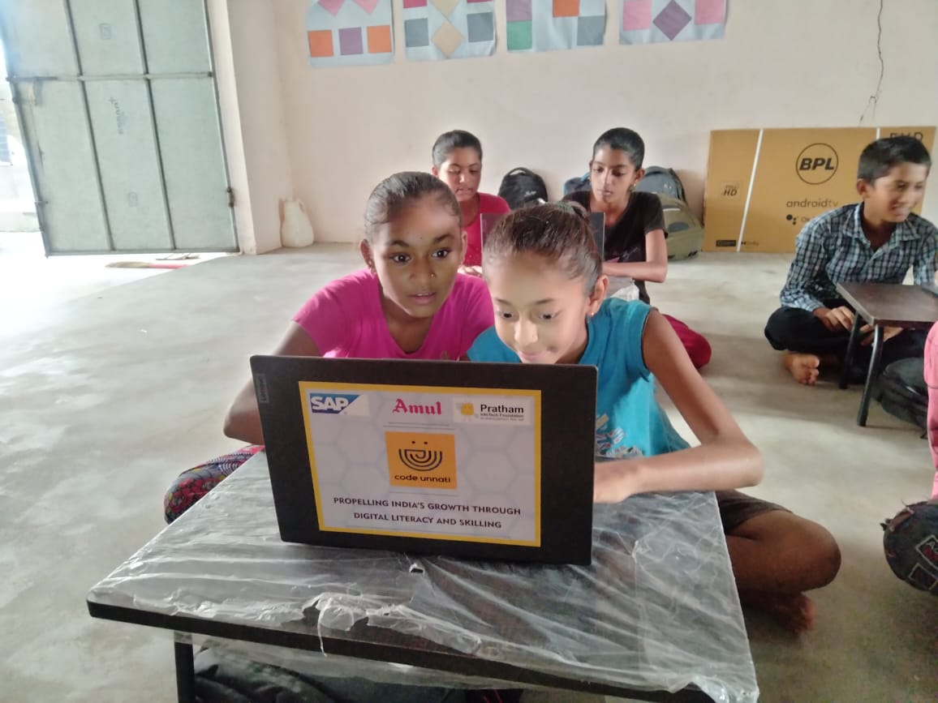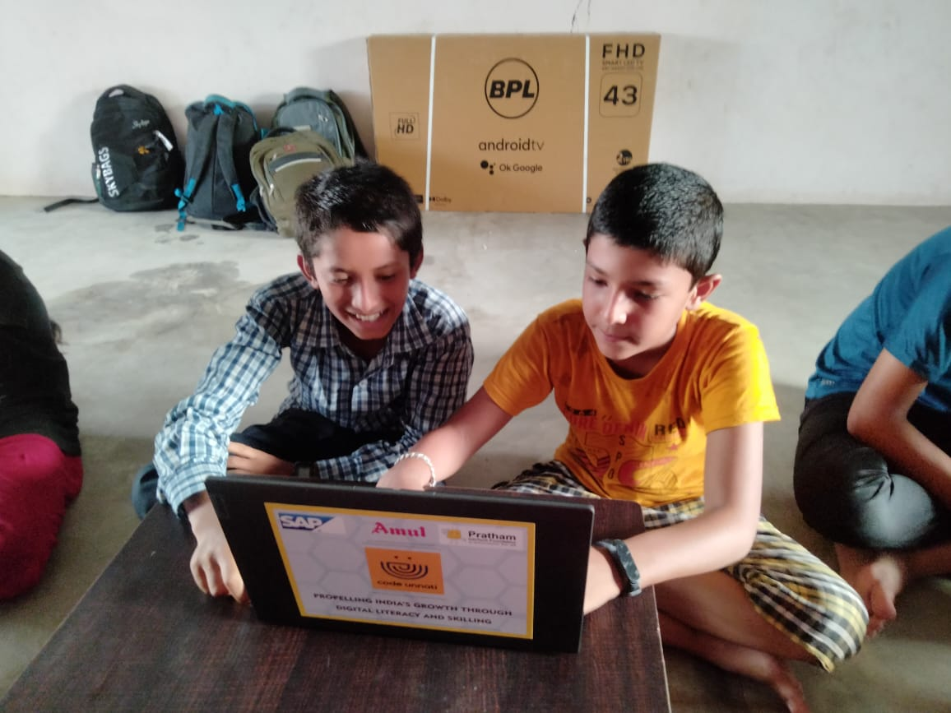

**Outcomes achieved so far are as under:**

* Students have improved in their academics especially in Maths, Science and Basic languages
* Confidence of students have increased a lot which is observed through their participation
* Life skill activities are helping students to think creatively and use their mind leading to generating curiosity among the students
* Students and parents find this centre very useful to them.
* Students especially love the extra activities that help in improving their thinking process.